6.102: In both cases, a given amount of fuel represents a given amount of work 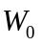 that the engine does in moving the plane forward against the resisting force. In terms of the range R and the (presumed) constant speed v,
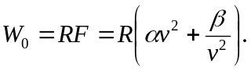
In terms of the time of flight 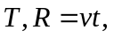 so
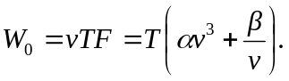
a) Rather than solve for R as a function of v, differentiate the first of these relations with respect to v, setting 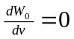 to obtain 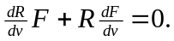 For the maximum range, 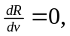 so 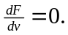 Performing the differentiation, 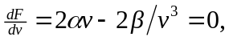 which is solved for
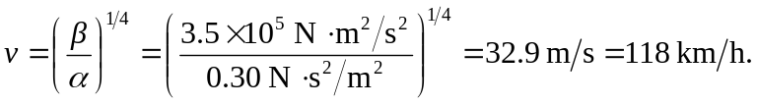
b) Similarly, the maximum time is found by setting 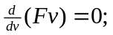 performing the differentiation, 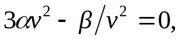 which is solved for
